Recursive function

**Python Recursive Function**

In Python, we know that a [function](https://www.programiz.com/python-programming/function) can call other functions. It is even possible for the function to call itself. These types of construct are termed as recursive functions.

Following is an example of a recursive function to [find the factorial of an integer](https://www.programiz.com/python-programming/examples/factorial).

Factorial of a number is the product of all the integers from 1 to that number. For example, the factorial of 6 (denoted as 6!)

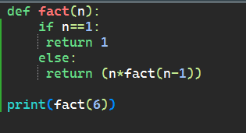

Output:

